**SMART ACCIDENT DETECTION AND ALERT SYSTEM**

A PROJECT REPORT

***Submitted by***

BL.EN. U4AIE21072 M. RAMYA SREE

BL.EN. U4AIE21080 METTU SIDDHARTHA

BL.EN. U4AIE21101 P. VAMSI VARDHAN REDDY

***in fulfillment of Project Phase -2* BACHELOR OF TECHNOLOGY** IN

COMPUTER SCIENCE ENGINEERING (ARTIFICIAL INTELLIGENCE)



AMRITA SCHOOL OF ENGINEERING, BANGALORE

AMRITA VISHWA VIDYAPEETHAM

**BANGALORE 560 035**

May-2021

**AMRITA VISHWA VIDYAPEETHAM**

**AMRITA SCHOOL OF ENGINEERING, BANGALORE, 560035**



**BONAFIDE CERTIFICATE**

This is to certify that the project report entitled **“SMART ACCIDENT DETECTION AND ALERT SYSTEM”** submitted by

BL.EN. U4AIE21072 M. RAMYA SREE

BL.EN. U4AIE21080 METTU SIDDHARTHA

BL.EN. U4AIE21101 POLI VAMSI VARDHAN REDDY

in partial fulfillment of the requirements for the award of the Degree- Bachelor of Technology in **“COMPUTER SCIENCE ENGINEERING (ARTIFICIAL INTELLIGENCE)”** is a bonafide record of the work carried out under my(our) guidance and supervision at Amrita School of Engineering, Bangalore.

SIGNATURE

|  |  |  |  |
| --- | --- | --- | --- |
|  | |  |  | | --- | --- | | **Ms. Sudha Yadav**  Assistant Professor Dept. of EEE |  | |

This project report was evaluated by us on 11/07/2022

|  |  |
| --- | --- |
|  | EXTERNAL EXAMINER |

# ACKNOWLEDGEMENT

We offer our sincere *pranams* at the lotus feet of Universal guru, **MATA AMRITANANDA MAYI DEVI** who showered her blessings throughout this project.

We are very thankful to **Br. Viswamrita Chaitanya Swamiji, Director**, Amrita School of Engineering, Bangalore, for his valuable support.

We are indebted to thank **Dr. Sriram Devanathan, Principal**, Amrita Vishwa Vidyapeetham, Bangalore for engraving a path for us to utilize the available resources to the fullest and there by widen our perspective of education and growth through it.

We deeply express our sincere thanks to **Dr. Amudha J, Chairperson**, Department of Computer Science Engineering for giving us the opportunity and encouraging us to use our abilities to the fullest in doing the project.

It is our privilege to express our sincerest regards to our project guide,

**Ms. Sudha Yadav, Assistant Professor**, Department of Electrical & Electronics Engineering, for the valuable inputs, guidance, encouragement, wholehearted cooperation and constructive criticism throughout the duration of our project.

We pay our respect and love to our parents, all other family members and friends for their love and encouragement throughout our project. We thank all for the same.

# ABSTRACT

Health is one of the most important factors in one’s life. Even taking care of one’s life is necessary. Nowadays, there are many accidents happening, especially many of them are travelling with car. The main objective of this project is to assist people to take care of their loved ones/ bedridden/bedrest patients by using GPS and GSM module.

Now a day's foundation has grown however the number of accidents is additionally getting increased even though numerous accidents are minor however because of the absence of medical aid and the range of rescue vehicles to the spot late so there is countless individuals who are losing the life consistently. In the current framework, human sees that accidents have happened and they will call to the rescue vehicle and the reach of the rescue vehicle to the spot is late because of that there is an enormous loss of human life, and in some of the system they only provided to send the alert message to the ambulance but not the location of victims. And, as per the World Health Organization, an expected 1.2 million individuals lose their lives every year because of car accidents. Commonly appropriate medical facilities are not given due to lack of communication thus leading to severe injuries. To decrease the number of people losing their lives in the proposed system, we are sending automatic information (i.e., location and alert message) to the ambulance, and the ambulance will arrive at the spot as soon as possible and can save human life and decrease number of individuals die every day. The proposed framework is to reduce the death rate of humans every day because of accidents by sending automatic location to the ambulance thus can save human life. And, the issue of vehicle theft has increased tremendously, mostly at gunpoint or in car parks. In view of these, there is a need to recover theft vehicles, identify and recovered vehicles which are not readily available in our society and as such especially important. We are going to add in the proposal so that we can get the location of the vehicle.

**TABLE OF CONTENTS**

|  |  |  |
| --- | --- | --- |
| **Chapter No** | **Title** | **Page No** |
| **1** | Introduction | 8 |
| **2** | Literature Survey | 9 |
| **3** | Design and Components | 10 |
| **4** | Methodology | 15 |
| **5** | Result and Analysis | 25 |
| **6** | Conclusion | 27 |
| **7** | Future Scope | 28 |
| **8** | References | 29 |

**LIST OF FIGURES**

|  |  |  |
| --- | --- | --- |
| **Sl. No** | **Figure** | **Page No.** |
| 1 | 3.1 | 10 |
| 2 | 3.2 | 12 |
| 3 | 3.3 | 12 |
| 4 | 3.4 | 13 |
| 5 | 3.5 | 13 |
| 6 | 3.6 | 13 |
| 7 | 3.7 | 14 |
| 8 | 4.1 | 15 |
| 9 | 4.2 | 16 |
| 10 | 4.3 | 17 |
| 11 | 4.4 | 17 |
| 12 | 4.5 | 18 |
| 13 | 4.6 | 19 |
| 14 | 4.7 | 22 |
| 15 | 5.1 | 25 |
| 16 | 5.2 | 25 |
| 17 | 5.3 | 26 |

**LIST OF ABBREVATIONS**

GPS- Global Positioning System

GSM- Global System for Mobile Communication

ANS- Accident Notification System

SMS- Short Message Service

**CHAPTER 1**

**INTRODUCTION**

Our project is for the automation of accident detection and notifying the hospitals, police stations and relatives about the accident. SMS will be sent to them with the help of GSM module and car tracing will be done with the help of GPS module and accelerometer detects the acceleration of the car when the accident happens airbag opens and the nitrogen gas is released then due to the valves present near the airbag the pushbutton is pressed then the accelerometer activates and engines stops running and alarm starts and SMS will be sent if the person meets with the small accident, then the message will be terminated. The proposed device is for Accident Notification System (A.N.S). This product will be used in vehicles to get the data of accident and further notifying police station and hospitals. This will reduce the number of deaths in accident cases and will help to track the data of car.

**CHAPTER 2**

**LITERATURE SURVEY**

## **Extensive Surveys**

In paper [1] we look at existing literature to see how various methods detect road accidents and inform emergency Services. The System effectively monitors the bicycle to know whether it is in a normal driving position or has fallen over.

The proposed system in this paper uses an accelerometer built into the Smartphone to detect an accident. This application holds up 15 seconds when the system is tilted over the specified limit and the accelerometer identifies it. The GPS module in this system is used to obtain the current position which is sent with a pre-recorded message to the emergency ambulance response team.

The proposed system follows the methodology as follows: A vibration sensor is utilized to quantify the vibration prompted by the vehicle’s crash. An ultrasonic sensor will recognize the presence of an individual inside the vehicle. The entire system will not be set off if the sensor does not detect the presence of an individual. A micro-controller that reads the vibration frequencies will set the GPS module to get the mishap’s coordinates. The GPS component gives the coordinates to the micro-controller, which uses the GSM module to transmit the coordinates to the emergency contacts by SMS as a Google Maps URL.

## **Conclusion**

The survey gave a brief idea of the existing technology and its defects. Over the years the importance of car safety has increased, and the top priority now is to reduce the medical response time when an accident occurs. The system is helpful as the accident victims will be treated by the emergency team as soon as possible decreasing the chances of any major disabilities.

**CHAPTER 3**

**DESIGN AND COMPONENTS**

**INTRODUCTION**

The entire project has three different Systems, GPS System, Accelerometer System and Buzzer System. Different components were used in the implementation of these three systems. While the following points will explain all the major components which are used in developing the project are explained in detail.

## **GPS System**

This is the first part of the system where it sends the alert message to the nearby hospitals and police station.

## **Circuit**

Fig 3.1 shows the Circuit of GPS System which was implemented in the project and different components were used in designing the hardware as well. The components which were used this system are explained in detail.

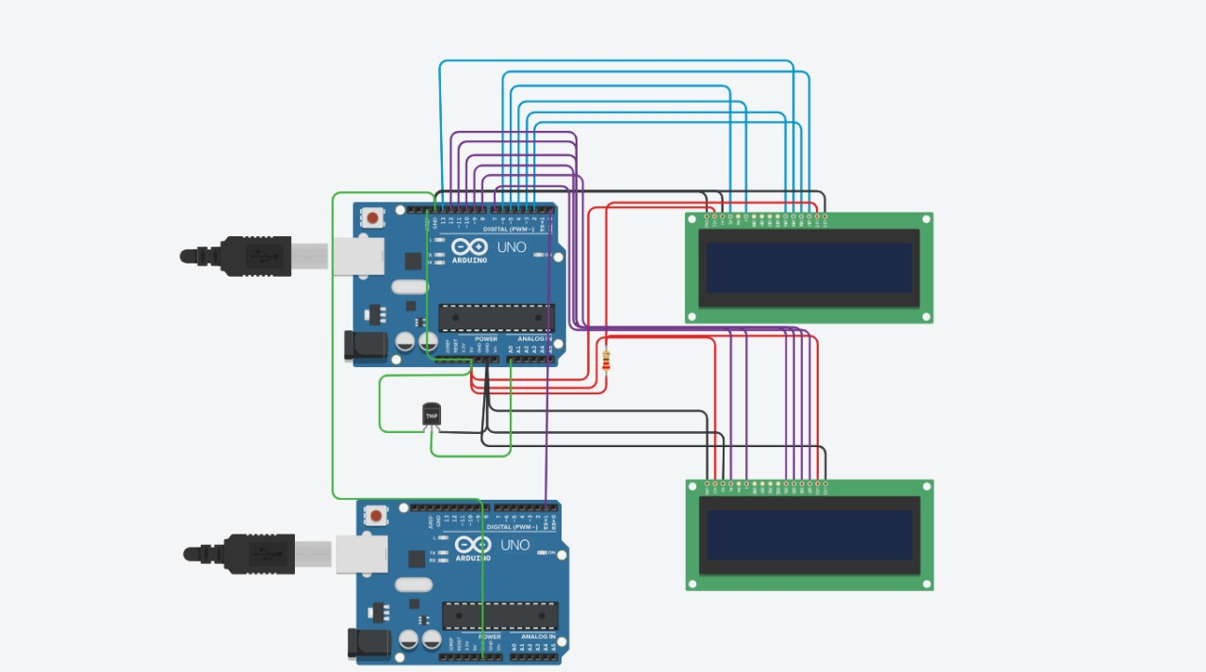

Fig 3.1

The prime components of this system are

* Arduino UNO R3
* LCD 16 x 2 display
* Temperature Sensor
* Accelerometer (Spark fun MMA7361 Breakout)
* Battery Source (9V)
* Resistor
* Piezo buzzer

**Arduino UNO R3**

The Arduino uno r3 is the frequently used microcontroller board. This is the latest version of an Arduino board released in the year 2011. The main feature of this board mainly includes it is available in DIP (dual-inline-package), detachable and ATmega238 microcontroller. The programming of this board can be easily be loaded by using an Arduino computer program. This board has a huge support from the Arduino community, which will make a very simple way to start working in embedded electronics, and many more applications.

The Arduino Uno R3 pin diagram is shown below. It comprises 14-digit I/O pins. From these pins, 6-pins can be utilized like PWM outputs. This board includes 14 digital input/output pins, Analog inputs-6, a USB connection, quartz crystal-16 MHz, a power jack, a USB connection, resonator-16Mhz, a power jack, an ICSP header an RST button. The power supply of the Arduino can be done with the help of an exterior power supply otherwise USB connection. The exterior power supply (6 to 20 volts) mainly includes a battery or an AC to DC adapter. The connection of an adapter can be done by plugging a center-positive plug (2.1mm) into the power jack on the board. The battery terminals can be placed in the pins of Vin as well as GND. The power pins of an Arduino board include the following. Vin: The input voltage or Vin to the Arduino while it is using an exterior power supply opposite to volts from the connection of USB or else RPS (regulated power supply). By using this pin, one can supply the voltage.5Volts: The RPS can be used to give the power supply to the microcontroller as well as components which are used on the Arduino board. This can approach from the input voltage through a regulator.3V3: A 3.3 supply voltage can be generated with the onboard regulator, and the highest draw current will be 50 mA.

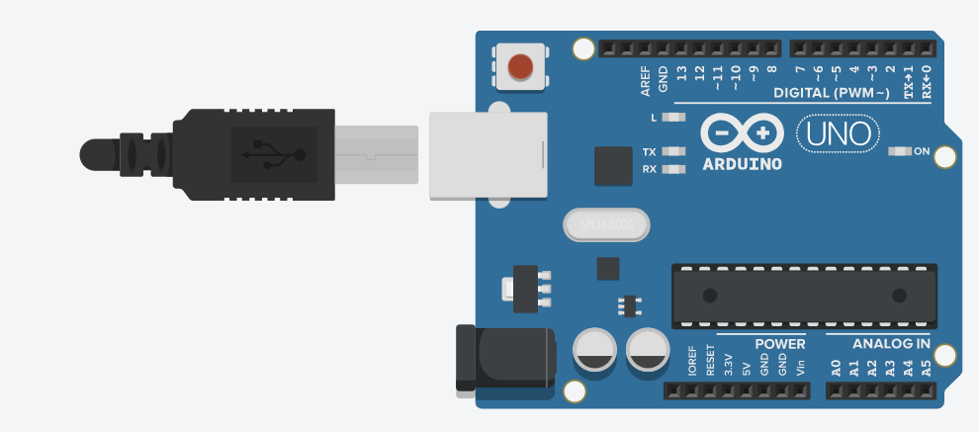

Fig. 3.2

**LCD display**

LCD stands for Liquid Crystal Display for where it uses Liquid Crystal to display visible images. Here we used 16 X 2 display as it is commonly used in these types of circuits. Each character is displayed in the form of pixels. In this particular LCD it has 5 X 8 dots with cursor. It even has KS 0066 built in controller. It is available with power supply of +5V and its duty cycle is 1/16. These LCDs are energy efficient as it consumes low power and they are long lasting. Also, there are no screen burnings. It even supports small and low-profile sizes, thereby it is cost efficient compared to other displays.

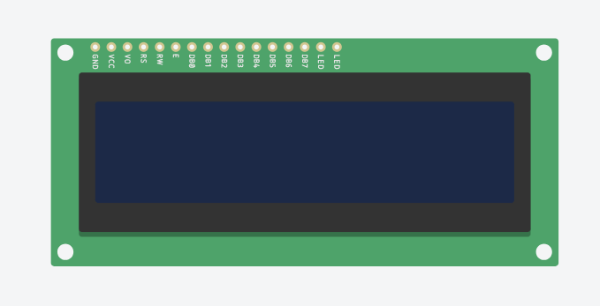

Fig. 3.3

**Temperature sensor**

Temperature sensor senses the temperature around the car when the accident occurred and temperature will be sent through the GSM module. Temperature sensor contains 3-pins one is connected to the around and the other is connected to the 5volts pin of the Arduino board and the middle pin is connected to the analog pin of the Arduino board.



Fig. 3.4

**Accelerometer**

An accelerometer comes in the form of a simple circuit for a large electronic device. Despite the humble appearance, the accelerometer is made of different parts and works in many ways. The voltage across x , y and z axis will be sent through the XOUT, YOUT, and ZOUT pins of accelerometer (i.e., Spark fun MMA7361 breakout) which are connected to the Arduino uno R3.

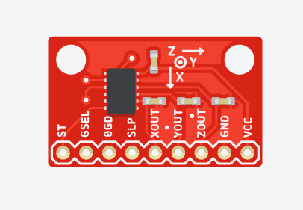

Fig.3.5

**Resistor**

Resistor is defined as A passive electrical component with two terminals that are used for either limiting or regulating the flow of electric current in electrical circuits. The main purpose of resistor is to reduce the current flow and to lower the voltage in any particular portion of the circuit.

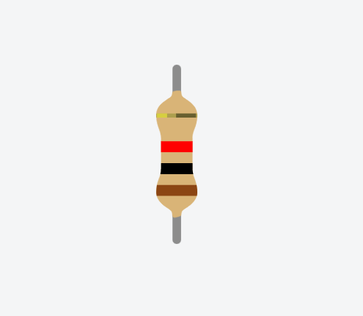

Fig.3.6

**Piezo buzzer**

A piezo buzzer is a type of electronic device that’s used to produce a tone, alarm or sound. It’s lightweight with a simple construction, when the accident happens accelerometer activates then the buzzer starts so that the public can get to know about the accident so the injured person can be taken to the hospital.



Fig.3.7

**Conclusion**

The above points give an overview on what all components are used in the project and how the components play a key role in the working of the prototype. It even explains technical data of the components.

**CHAPTER 4**

**METHODOLOGY**

**Introduction**

This chapter just gives the overview of the methodology that was used to implement this project. The following figures shows the block diagram of how the accident takes places and how the notification system sends the information related to the accident.

**Rough sketch**

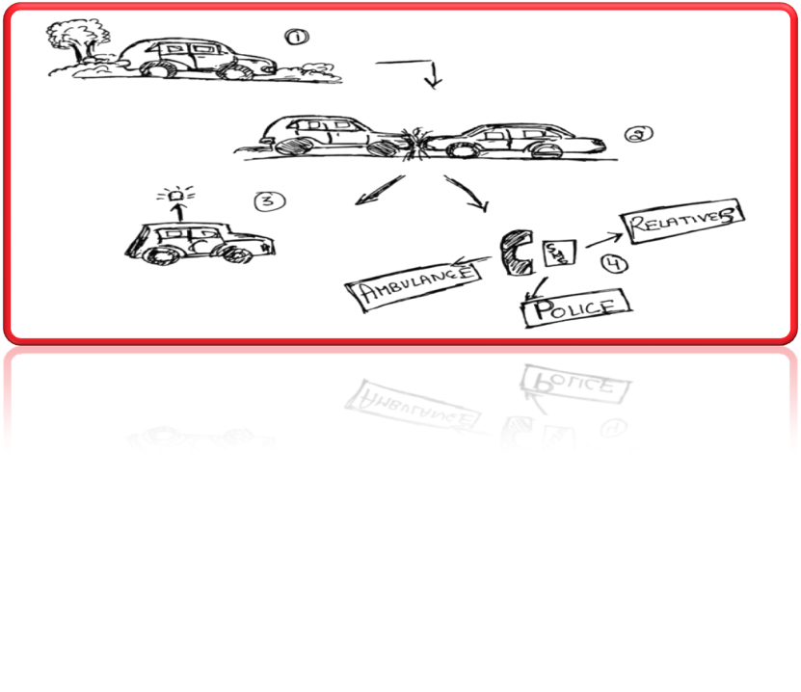

Fig.4.1

When the car is moving

If suddenly any accident takes place anywhere.

Our project helps in notifying about the accident by its sound system.

Then our accidental and informer system will notify to person’s family / relatives, to police & to ambulance or nearby hospital

**Block Diagram**

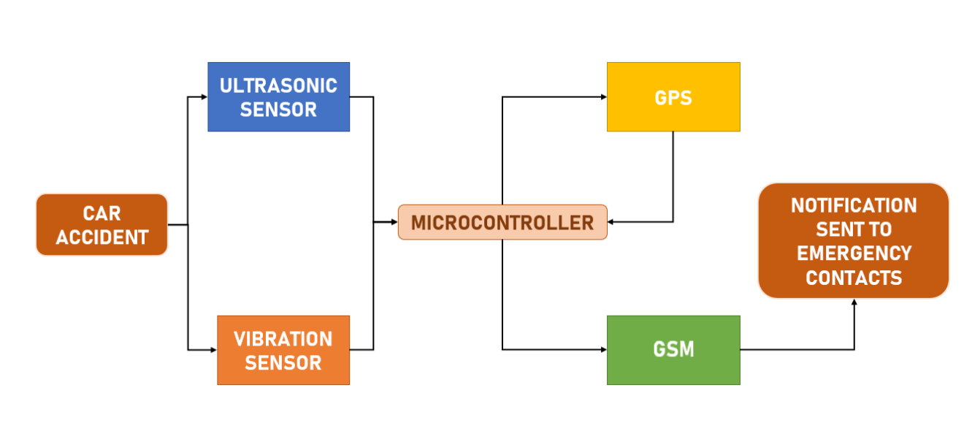

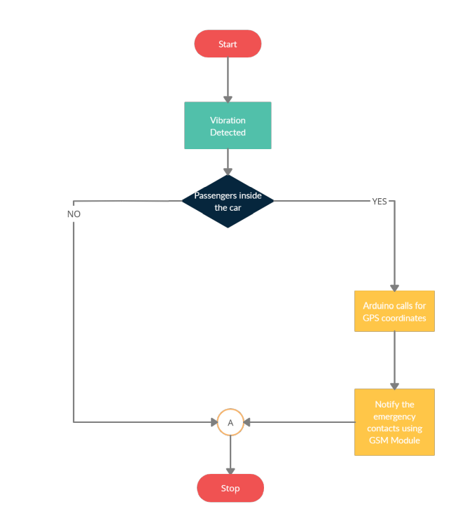

Fig.4.2

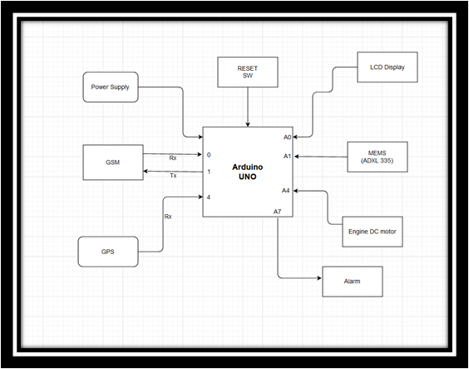

Fig.4.3

Arduino board is connected to the power supply, GSM and GPS modules, LCD display, Accelerometer, and DC motor. When the accident happens then the accelerometer gets alert and GSM module receives the input from the accelerometer and it activates through the help of GPS module the place where the accident happened is sent to the police station, hospital, or relatives. When the accelerometer activates the buzzer starts so the public near by can get to know about the accident.

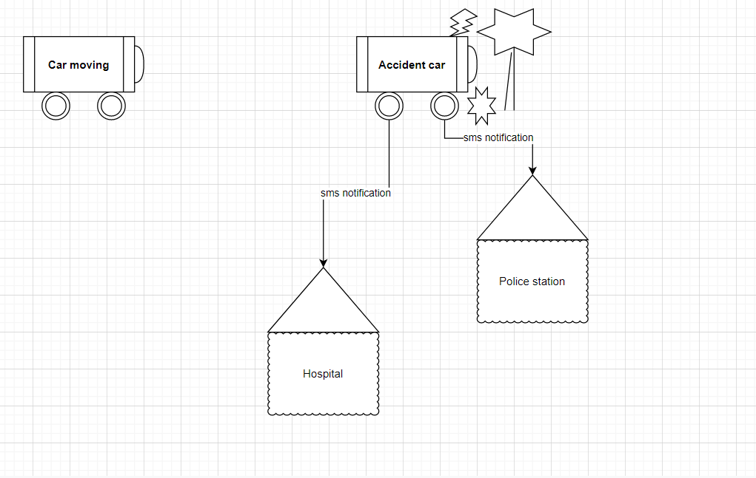

Fig.4.4

**Simulation Circuit:**

GLOBAL POSITIONING SYSTEM (GPS) CIRCUIT



Fig.4.5

**Code:**

char text1[] = "$GPVTG,054.7,T,034.4,M,005.5,N,010.2,K";

char text2[] = "$GPGGA,134658.00,5106.9792,N,11402.3003,W,2,SMS,1.0,1048.47,M,-16.27,M,08,AAAA*60";

void setup()

{

Serial.begin(9600);

}

void loop()

{

delay(200);

Serial.write(text1);

Serial.write("/");

delay(500);

Serial.write(text2);

delay(500);

Serial.write("/");

Serial.write("SMS sent");

delay(1000);

}

ACCELERO METER USING ADXL-335

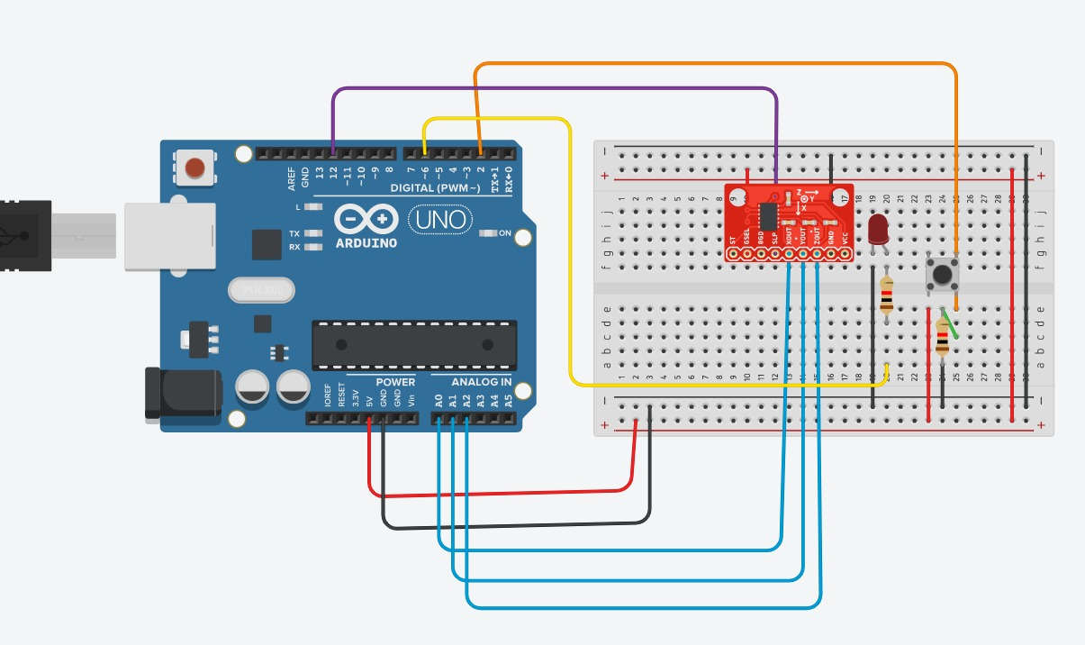

Fig.4.6

**Code:**

//int Buttonstate=0;

void setup()

{

Serial.begin(9600);

pinMode(12,OUTPUT);

pinMode(12,INPUT);

//pinMode(2,INPUT);

pinMode(6,OUTPUT);

attachInterrupt(0,funcion,RISING);

sei();

}

float atotal;

void loop()

{

/*Buttonstate=digitalRead(2);

if(Buttonstate==HIGH)

{

digitalWrite(6,HIGH);

}

else{

digitalWrite(6,LOW);

}*/

int x = analogRead(A0);

int y = analogRead(A1);

int z = analogRead(A2);

float vx = (5.0*x)/1023.0;

float vy = (5.0*y)/1023.0;

float vz = (5.0*z)/1023.0;

float gx = (vx-1.65)/0.206;

float gy = (vy-1.65)/0.206;

float gz = (vz-1.65)/0.206;

float atotal = sqrt(gx*gx + gy*gy + gz*gz);

Serial.println(" ");

Serial.print("x: ");

Serial.print(x);

Serial.print(", voltx: ");

Serial.print(vx);

Serial.print(", g pres x: ");

Serial.print(gx);

Serial.print(" ||y: ");

Serial.print(y);

Serial.print(", volty: ");

Serial.print(vy);

Serial.print(", g pres y: ");

Serial.print(gy);

Serial.print(" ||z: ");

Serial.print(z);

Serial.print(", voltz: ");

Serial.print(vz);

Serial.print(", g pres z: ");

Serial.println(gx);

Serial.println("------------");

Serial.print("acceleration total: ");

Serial.print(atotal);//13.87

Serial.println(" ");

Serial.println("------------");

if(atotal > 1.4){

digitalWrite(6,HIGH);

}

if(digitalRead(12)==HIGH){

Serial.print("Aceleracion Total: ");

Serial.println(atotal);

}

delay(1000);

}

void funcion(){

if(digitalRead(12)== HIGH){

digitalWrite(12,LOW);

}else{

digitalWrite(12,HIGH);

} }

BUZZER ALARM DETECTION

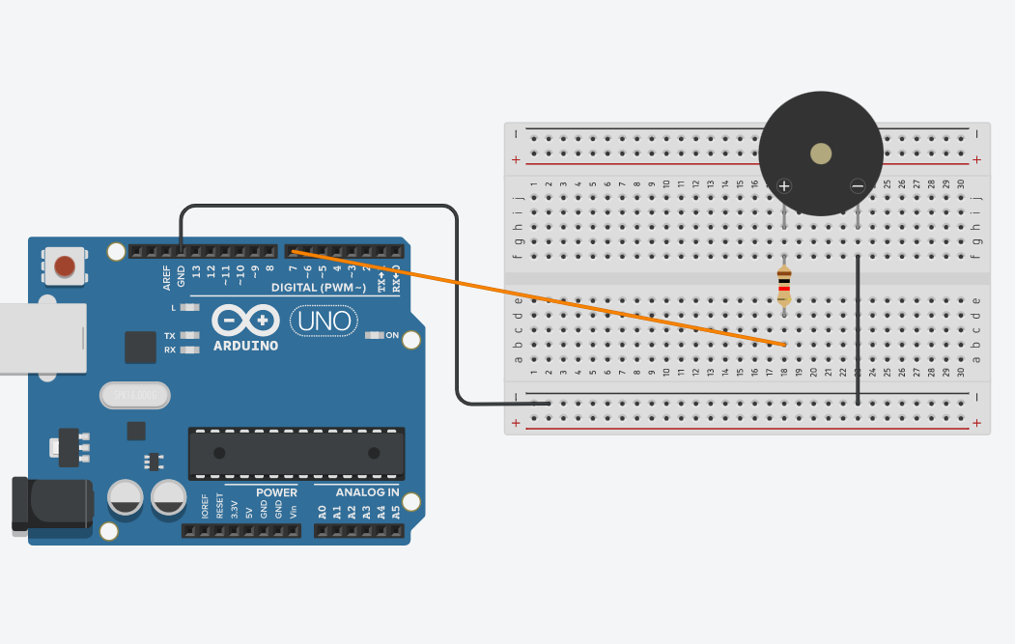

Fig.4.7

**Code:**

void setup() {

pinMode(7, OUTPUT);

}

void loop(){

tone(7, 220, 100);

delay(200);

}

**Schematic diagram**

ACCELERO METER  USING ADXL-335

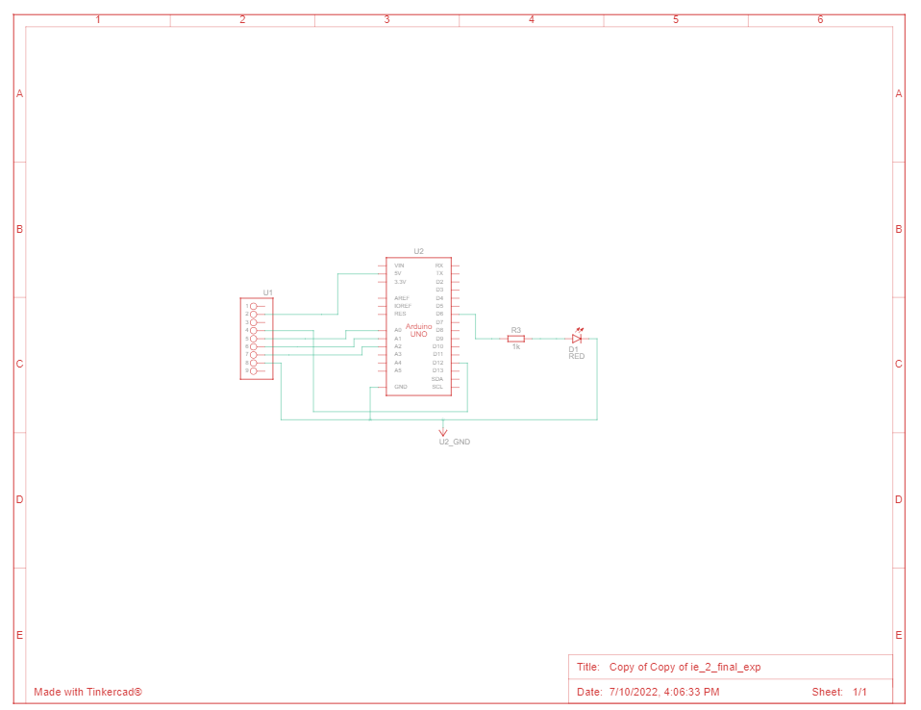

BUZZER ALARM DETECTION

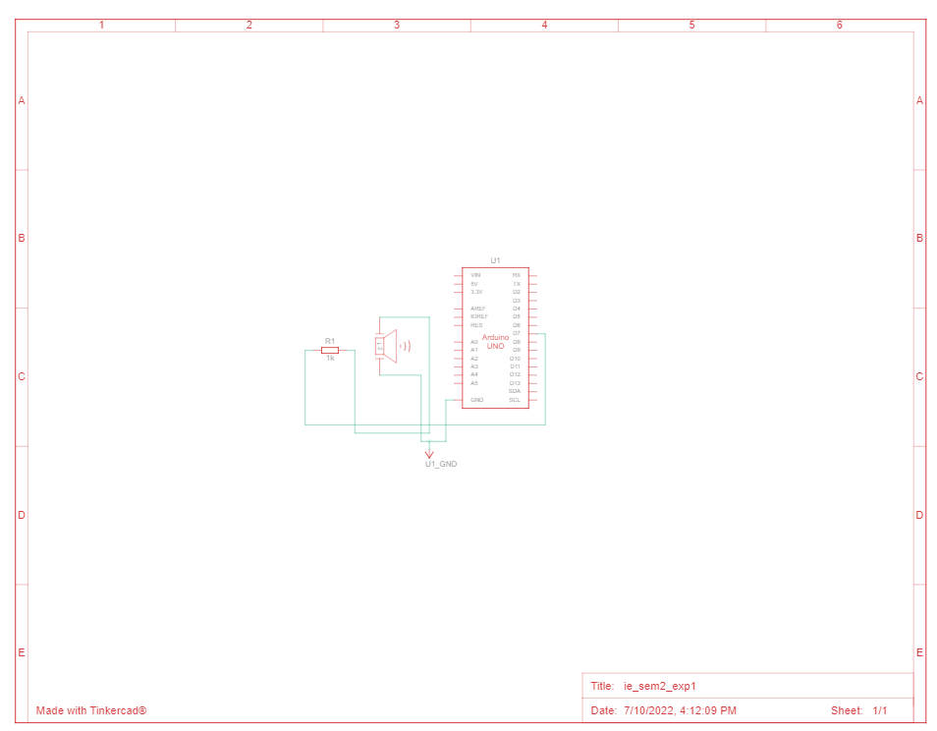

GLOBAL POSITIONING SYSTEM (GPS)

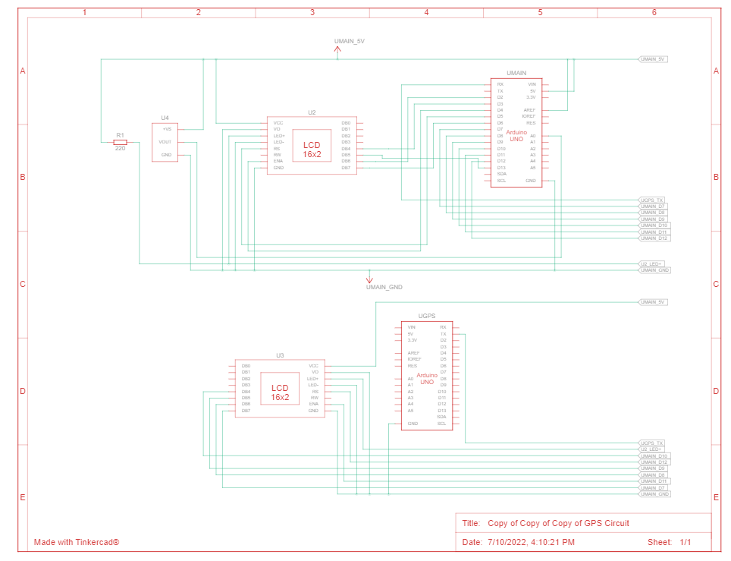

**CHAPTER 5**

**RESULT AND ANALYSIS**

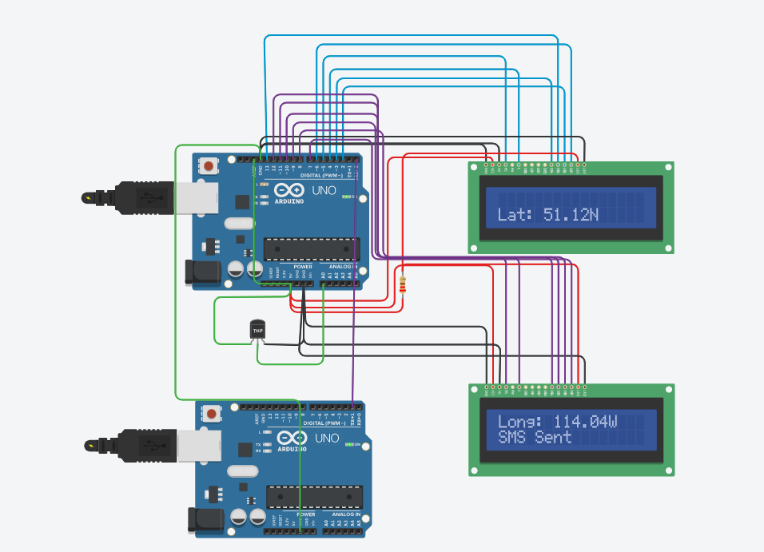

Fig.5.1

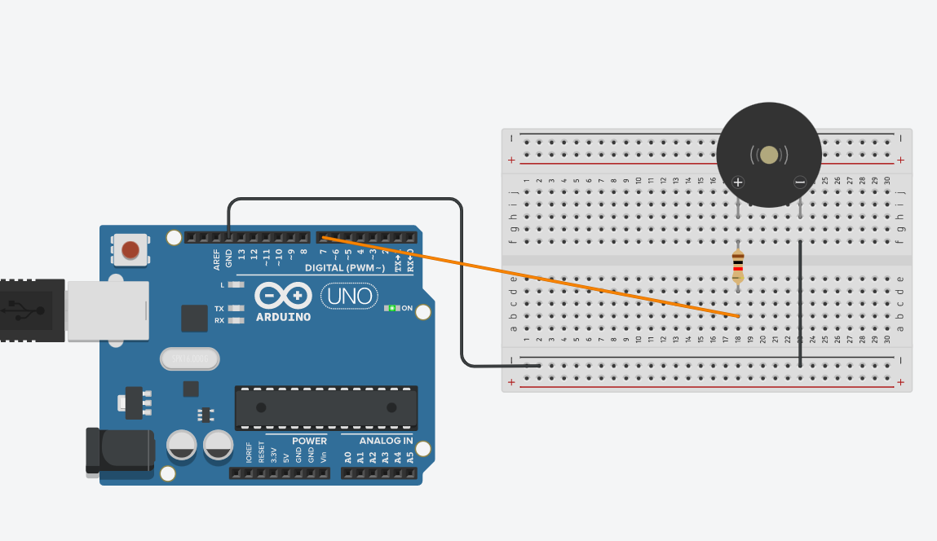

Fig.5.2

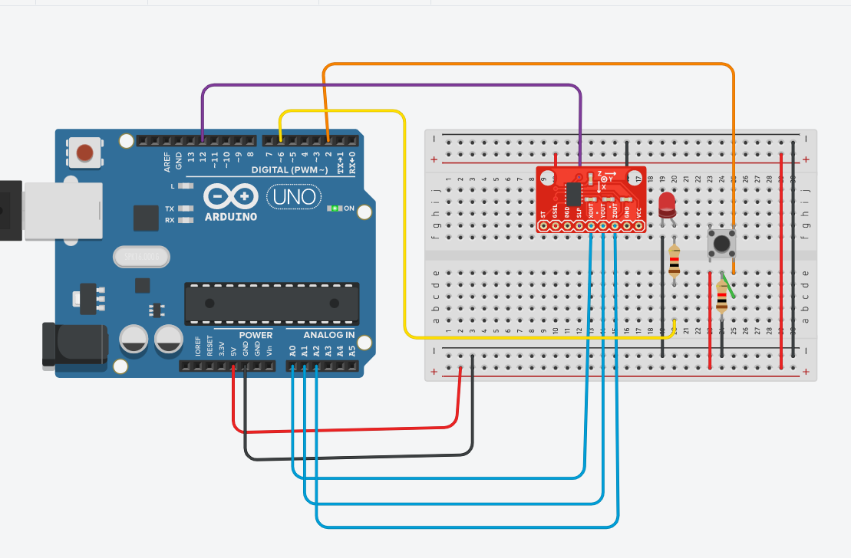

Fig.5.3

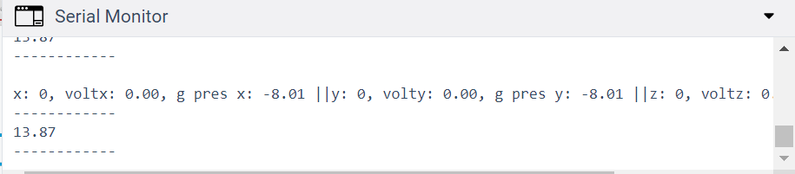

The proposed system here detects the occurrence of an accident and sends an alert message to the emergency contacts containing the GPS coordinates and the Google Map link of the detected accident location. After performing various tests and adjusting the threshold value of the vibrations, whenever a vibration greater than the threshold value was detected the buzzer goes off alerting the passengers inside the car. A response time of 30 seconds is also added in a case where the passengers inside are safe and no urgent help is required they can prevent an alert message from being sent to the listed emergency contacts by pressing a button. In a situation where there was no response, the GPS Module provides the coordinates of the accident location and the GSM Module delivers the message to the listed emergency contacts. This was also tested multiple times and proved to be successful as the message was received on the provided emergency contact during all the tests. As a result, this system helps in providing quick medical help to the victims of the accident and thus increasing the chances of saving their lives.

**CHAPTER 6**

**CONCLUSION**

Our goal of this project is

* This will reduce the no of deaths in accident cases and will help to track data of car. Also helps to solve various cases of road accident and will able to find the culprit.
* GPS tracking system to be enabled in car.
* Instant notification system to be enabled to notify hospital in alarming case.
* Sound notification in hospital and message notification with location.
* In case of lost car GPS will track car and detect the location.
* Recorded data of car movement will be maintained.
* GPS system to be attached with car no. and owner details.
* After accident sound alarm will be played and then will be cached by sound sensor which further will send notification.
* Notification will be sent with car number and owner details.
* After searching for car details will get actual location of cars and can contact owner.
* Mainly our project helps to save lives of many people.

Over the years the importance of car safety has increased, and the top priority now is to reduce the medical response time when an accident occurs. The system is helpful as the accident victims will be treated by the emergency team as soon as possible decreasing the chances of any major disabilities. This concept will save the victim’s life by shortening the time it takes for emergency services to get to the scene of the accident. It notifies emergency contacts and ensures that no valuable life is wasted that could have been spared if the medical team had come sooner. As a result, this paper offers an efficient approach to reducing the loss of valuable lives in road accidents.

**CHAPTER 7**

**FUTURE SCOPE**

**Safety Requirements**:

If there is any damage to the device then the second part attached with airbag inflator starts working which when gets excess of nitrogen pumps and on the sensor which further send the notification. Device should be properly fitted and attached properly to the vehicle.

**Security Requirement**:

Security Requirement requires proper maintenance and check after installation. Testing the system prototype before use is needed.

**Software Quality Attributes:**

Availability of proper hospital and police station should be near to easily track and notify.

**CHAPTER 8**

**REFERENCES**

[1] Kattukkaran, Nicky & George, Arun & T P, Mithun Haridas. (2017).”Intelligent accident detection and alert system for emergency medical assistance”. 1-6. 10.1109/ICCCI.2017.8117791.

[2] Vangala, Padmaja. (2012). ”Vehicle Accident Automatic Detection and Remote Alarm Device”. International Journal of Reconfigurable and Embedded Systems (IJRES). 1. 10.11591/ijres.v1i2.493.

[3] M. Young, The Technical Writer’s Handbook. Mill Valley, CA: University Science, 1989.

[4] Santos, S. (2019, June 19). Guide to NEO-6M GPS Module Arduino. Random Nerd Tutorials. https://randomnerdtutorials.com/guide-to-neo6m-gps-module-with-arduino/

[5] J. (2020, October 31). How to Interface GSM Module to Arduino-Send and Receive SMS. Electronic Circuits and Diagrams-Electronic Projects and Design. https://www.circuitstoday.com/interface-gsm-module-with arduino.